Programming in C Project

Submitted By: Harsh Kashyap
SAP ID: 590022724
Course: B.Tech CSE Batch: 36
Submitted To: Shubham Dubey
Parking Management System
An advanced system for managing vehicle parking with revenue tracking

ABSTRACT
This program implements a comprehensive Parking Management System in C that handles vehicle parking operations, revenue tracking, and slot management. The system allows users to park vehicles with different types (bike, car, truck) and VIP options, automatically generates unique ticket IDs for each vehicle, calculates parking bills based on duration and vehicle type with time-based discounts and coupon support, maintains a visual parking map showing slot occupancy, logs all transactions to a file for record keeping, and tracks total revenue generated. The system uses dynamic memory allocation, structures, time functions, and file operations. This project demonstrates practical application of advanced C programming concepts including memory management, time-based calculations, input validation, and real-world business logic implementation.

FEATURES
- Dynamic Memory Allocation: Flexible slot count at runtime
- File-Based Logging: All transactions recorded in parking_log.txt
- Time-Based Billing: 10-second units with configurable rates
- VIP Support: Double pricing for VIP parking slots
- Discount System: Long stay discounts and coupon support
- Input Validation: Type checking and boundary validation

• Case-Insensitive Input: Flexible coupon entry
- Visual Parking Map: Grid-based slot display
- Status Dashboard: Real-time occupancy and revenue tracking
- Robust Error Handling: Graceful handling of edge cases

The Code
#include <stdio.h>
#include <stdlib.h>
#include <string.h>
#include <time.h>
#include <ctype.h>
typedef struct { int slot; char vehicleNo[20]; char ticketID[20]; char type[10]; int isVIP; time_t entryTime; int occupied;
} Parking; double totalRevenue = 0;
int isAlreadyParked(Parking *p, int n, char *num) { for (int i = 0; i < n; i++) if (p[i].occupied && strcmp(p[i].vehicleNo, num) == 0) return 1; return 0;
} void generateTicketID(char *id, int slot) { sprintf(id, "TKT%04d%02d", rand() % 9000 + 1000, slot);
}
void logToFile(Parking *v, double sec, double bill) { FILE *f = fopen("parking_log.txt", "a"); if (!f) {
printf("Error: Unable to open parking_log.txt for writing!\\n"); return; }
char entry[30], exitT[30]; struct tm *en = localtime(&v->entryTime); time_t ex = time(NULL); struct tm *exx = localtime(&ex); strftime(entry, 30, "%Y-%m-%d %H:%M:%S", en); strftime(exitT, 30, "%Y-%m-%d %H:%M:%S", exx); fprintf(f, "Ticket: %s\\nVehicle: %s\\nType: %s\\nSlot: %d\\nVIP: %d\\nEntry: %s\\nExit: %s\\nTime: %.2f sec\\nBill: %.2f\\n\\n", v->ticketID, v->vehicleNo, v->type, v->slot, v->isVIP, entry, exitT, sec, bill); fclose(f);
} double getRate(char *type) { if (strcmp(type, "bike") == 0) return 2; if (strcmp(type, "car") == 0) return 3; if (strcmp(type, "truck") == 0) return 5; return 2;
} int isValidType(char *type) { return strcmp(type, "bike") == 0 || strcmp(type, "car") == 0 || strcmp(type, "truck") == 0;
} void showParkingStatus(Parking *p, int n, double revenue) { int parkedCount = 0, vipCount = 0, emptyCount = 0; for (int i = 0; i < n; i++) { if (p[i].occupied) { parkedCount++; if (p[i].isVIP) vipCount++;
} else emptyCount++;
} printf("\\n========== PARKING STATUS ==========\\n"); printf("Total Slots: %d\\n", n); printf("Occupied Slots: %d\\n", parkedCount); printf("VIP Slots Occupied: %d\\n", vipCount); printf("Available Slots: %d\\n", emptyCount); printf("Total Revenue: Rs %.2f\\n", revenue); printf("====================================\\n");
} void showParkingMap(Parking *p, int n) { int columns = 3;
int rows = (n + columns - 1) / columns;
printf("\\n============= PARKING MAP =============\\n\\n"); for (int r = 0; r < rows; r++) { printf(" ");
for (int c = 0; c < columns; c++) { int idx = r * columns + c; if (idx < n) printf("+----------+ "); else printf(" ");
} printf("\\n ");
for (int c = 0; c < columns; c++) { int idx = r * columns + c; if (idx < n) printf("| Slot %-3d | ", idx + 1); else printf(" ");
} printf("\\n "); for (int c = 0; c < columns; c++) { int idx = r * columns + c; if (idx < n) printf("| %-8s | ", p[idx].occupied ?
p[idx].vehicleNo : "EMPTY"); else printf(" ");
} printf("\\n "); for (int c = 0; c < columns; c++) { int idx = r * columns + c; if (idx < n) printf("+----------+ "); else printf(" ");
} printf("\\n\\n");
} printf("============== END MAP ==============\\n");
} void parkVehicle(Parking *p, int n) { char num[20], type[10]; int vip; printf("Enter Vehicle Number: "); scanf("%19s", num); if (isAlreadyParked(p, n, num)) { printf("Vehicle already parked.\\n"); return; } printf("Vehicle Type (bike/car/truck): "); scanf("%9s", type); if (!isValidType(type)) { printf("Invalid vehicle type! Only bike, car, truck allowed.\\n"); return; }
printf("VIP Slot? (1=Yes, 0=No): "); scanf("%d", &vip); for (int i = 0; i < n; i++) { if (!p[i].occupied) { strcpy(p[i].vehicleNo, num); strcpy(p[i].type, type); p[i].isVIP = vip; p[i].entryTime = time(NULL); p[i].occupied = 1; generateTicketID(p[i].ticketID, i + 1); printf("Vehicle Parked at Slot %d\\n", i + 1); printf("Ticket ID: %s\\n", p[i].ticketID); return;
} } printf("Parking Full\\n"); } void removeVehicle(Parking *p, int n) { char ticket[20], coupon[20]; printf("Enter Ticket ID: "); scanf("%19s", ticket); for (int i = 0; i < n; i++) { if (p[i].occupied && strcmp(p[i].ticketID, ticket) == 0) { time_t exitTime = time(NULL); double sec = difftime(exitTime, p[i].entryTime); double units = sec / 10.0; if (units < 1) units = 1; double rate = getRate(p[i].type); if (p[i].isVIP) rate *= 2; double bill = units * rate; if (sec < 30) printf("Stay Category: Short Stay\\n"); else if (sec <= 120) printf("Stay Category: Medium Stay\\n"); else printf("Stay Category: Long Stay (10%% discount)\\n"), bill *= 0.9; printf("Apply Coupon? (type NONE for no): "); scanf("%19s", coupon); for (int j = 0; coupon[j]; j++) coupon[j] = toupper(coupon[j]); if (strcmp(coupon, "SAVE10") == 0) bill *= 0.90; totalRevenue += bill; printf("Slot: %d\\n", i + 1); printf("Time Parked: %.2f sec\\n", sec); printf("Bill: Rs %.2f\\n", bill); printf("Total Earnings: Rs %.2f\\n", totalRevenue); logToFile(&p[i], sec, bill); p[i].occupied = 0; p[i].vehicleNo[0] = '\\0'; p[i].ticketID[0] = '\\0'; return;
} }
printf("Invalid Ticket ID\\n");
} int main() { srand(time(NULL)); int n, choice;
printf("Enter number of parking slots: "); if (scanf("%d", &n) != 1 || n < 1) { printf("Invalid slot number!\\n"); return 1;
}
Parking *p = (Parking *)malloc(n * sizeof(Parking));
for (int i = 0; i < n; i++) { p[i].slot = i + 1; p[i].occupied = 0;
} while (1) {
printf("\\n1. Park Vehicle\\n2. Remove Vehicle\\n3. Display Status\\n4. Parking Map\\n5. Exit\\nEnter Choice: "); scanf("%d", &choice); if (choice == 1) parkVehicle(p, n); else if (choice == 2) removeVehicle(p, n); else if (choice == 3) showParkingStatus(p, n, totalRevenue); else if (choice == 4) showParkingMap(p, n); else if (choice == 5) break; else printf("Invalid Choice\\n");
} free(p);
return 0;
}

Step By Step Explanation of Code

1. Include Directives and Structure Definition
The program begins by including essential libraries: stdio.h for input/output, stdlib.h for dynamic memory functions, string.h for string operations, time.h for timestamp management, and ctype.h for character conversion. The Parking structure is defined using typedef, encapsulating seven fields that represent a parking slot's complete state including slot number, vehicle registration, unique ticket identifier, vehicle category, VIP status flag, entry timestamp, and occupancy indicator.
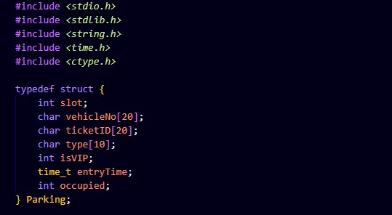

2. Global Revenue Tracker
A global variable totalRevenue maintains cumulative earnings across all parking transactions. Using a global ensures this value persists throughout program execution and remains accessible to all functions without parameter passing, making revenue tracking seamless across multiple vehicle check-ins and check-outs.

3. Duplicate Detection Function
The isAlreadyParked function prevents double-parking violations by scanning all occupied slots and comparing vehicle registration numbers using strcmp. This validation ensures parking integrity by rejecting any attempt to park a vehicle that already has an active parking session, returning 1 if found and 0 otherwise.
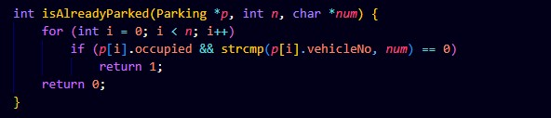

4. Unique Ticket Generation
generateTicketID creates distinctive identifiers by combining a random 4-digit number with a 2-digit slot number using sprintf formatting. The rand function generates pseudo-random values seeded at program start, producing tickets in the format TKT followed by 6 digits, ensuring each parking session has a traceable unique reference.


5. Transaction Logging System
The logToFile function appends comprehensive parking records to parking_log.txt using file append mode. It converts UNIX timestamps to human-readable formats using localtime and strftime, recording ticket ID, vehicle details, slot number, VIP status, precise entry and exit times, parking duration, and final bill amount for audit trail maintenance.
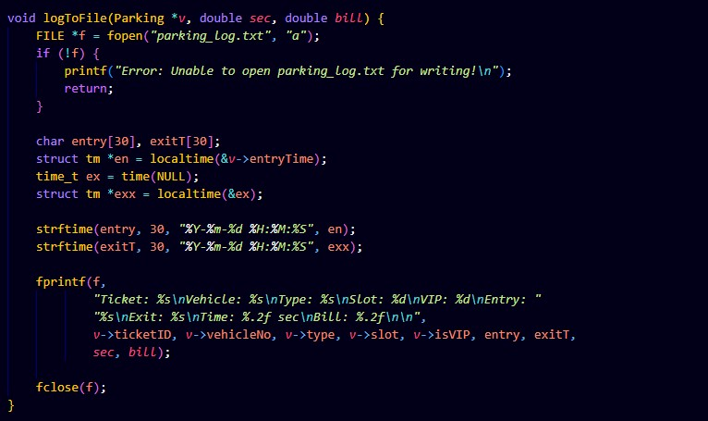

6. Rate Calculation Logic
getRate determines base parking charges by vehicle type classification: bikes are charged Rs 2 per billing unit, cars Rs 3, and trucks Rs 5. This tiered pricing structure reflects vehicle size and space consumption, with a default fallback to bike rates for unrecognized types ensuring system robustness.
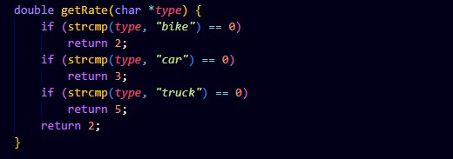

7. Input Validation Function
isValidType enforces strict vehicle category validation by checking input strings against three permitted types: bike, car, and truck. This function prevents billing errors and ensures consistent rate application by rejecting any non-standard vehicle classifications before they enter the parking system.

8. Status Display Function
showParkingStatus provides real-time system analytics by iterating through all slots to count occupied spaces, VIP occupancy, and available capacity. It presents a formatted summary including total slots, current occupancy levels, VIP slot usage, remaining capacity, and accumulated revenue, giving operators instant operational visibility.
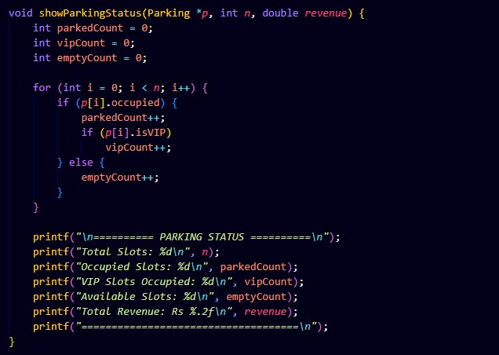

9. Visual Parking Map
showParkingMap renders a text-based grid representation of parking lot status arranged in 3-column rows. The function dynamically adjusts to any slot count by calculating required rows, then prints formatted borders, slot numbers, and occupancy status (vehicle number or EMPTY) in aligned columns, providing operators with intuitive visual slot monitoring.
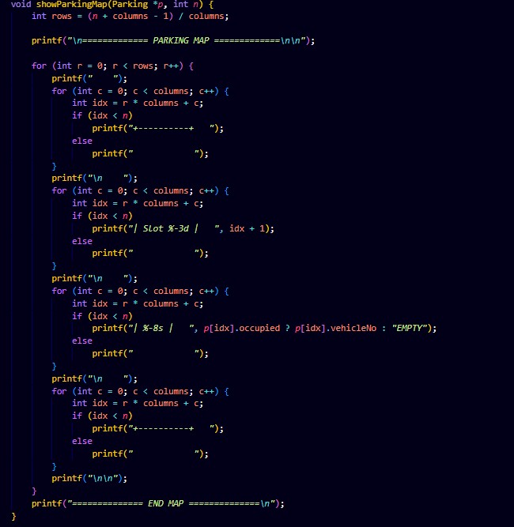

10. Vehicle Parking Workflow
parkVehicle orchestrates the check-in process by first prompting for vehicle registration and validating against duplicate entries. After confirming vehicle type validity and VIP preference, it scans for the first available slot, populates that slot's structure fields with entry data, generates a unique ticket, displays confirmation with slot and ticket details, and updates occupancy status.
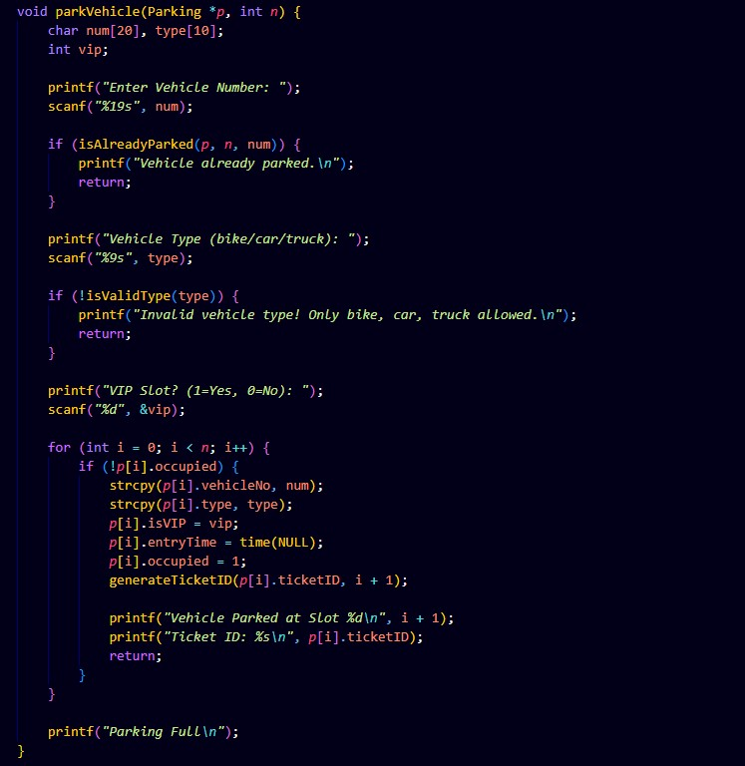

11. Revenue Calculation System
The removeVehicle function implements sophisticated billing by calculating parking duration in seconds using difftime, converting time to billing units at 10 seconds per unit with a 1-unit minimum. Base rates are multiplied by vehicle type, doubled for VIP status, reduced by 10 percent for long stays exceeding 120 seconds, and further discounted by 10 percent if the SAVE10 coupon is applied in a case-insensitive manner.
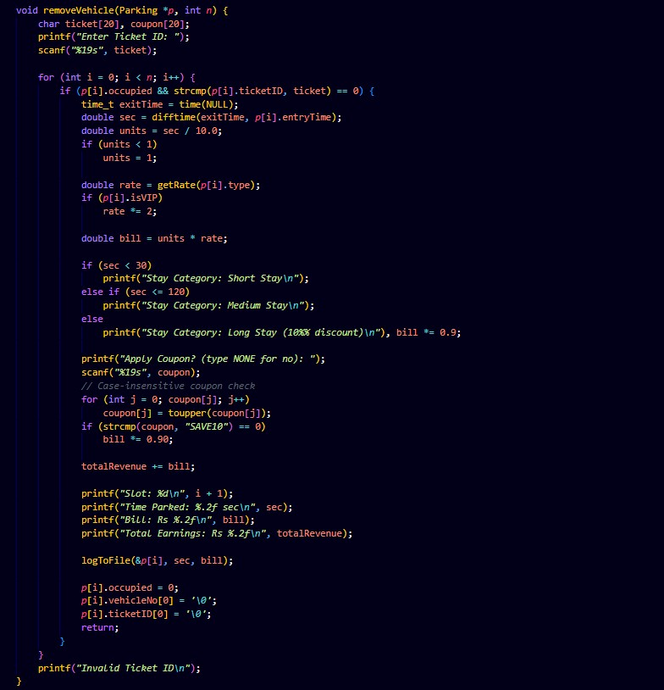

12. Memory Management and Main Loop
The main function initializes random seed, validates slot count input for positive integers, dynamically allocates a Parking array using malloc, initializes all slots to unoccupied state, then enters a menu-driven loop presenting five options. User selections trigger corresponding functions until exit is chosen, after which free releases allocated memory preventing leaks and ensuring clean program termination.
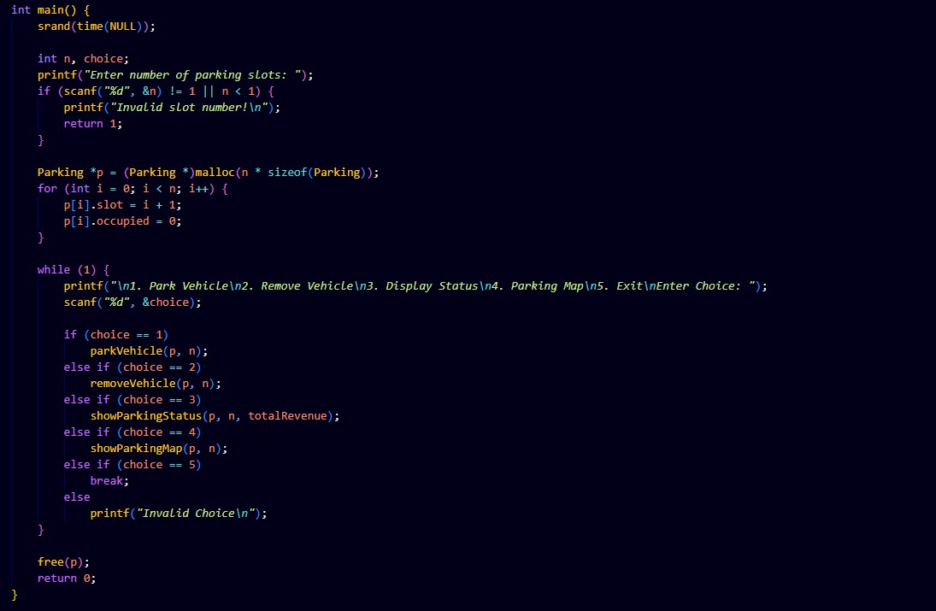

TEST CASES

Test Case 1: Park Multiple Vehicles
Input: Park 3 vehicles - DL01AB12 (car, non-VIP), MH02CD56 (bike, VIP), UP03EF90 (truck, non-VIP) in a 5-slot parking
Output:
The system accepts the first vehicle DL01AB12 as a car in slot 1, generates ticket
TKT578401, and confirms parking. The second vehicle MH02CD56 is parked in slot 2 with VIP status, ticket TKT898002 is generated. The third vehicle UP03EF90 occupies slot 3 as a truck with ticket TKT627903. All vehicles are successfully registered with unique tickets and the parking map shows 3 occupied slots and 2 empty slots.
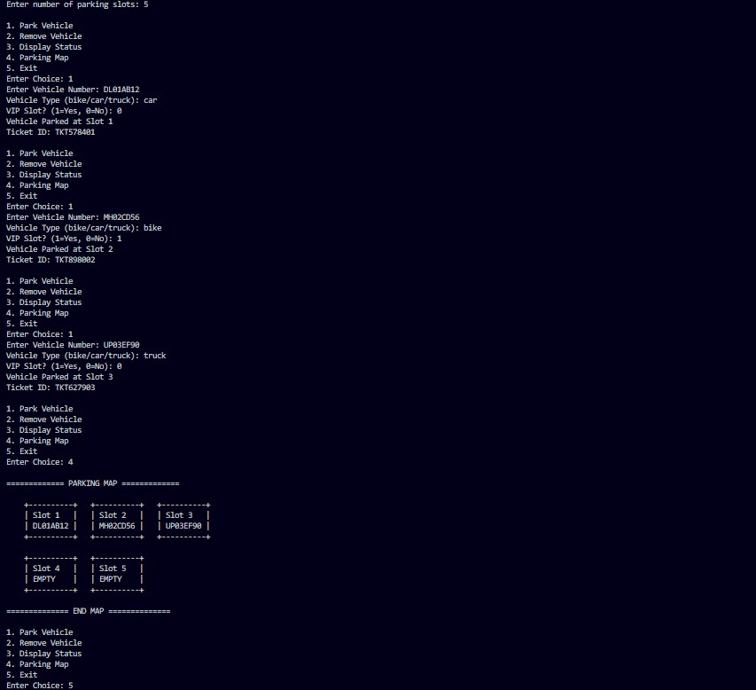

Test Case 2: Billing with VIP and Duration Discount
Input: Park MH02CD56 (bike, VIP) for 154 seconds, then remove with ticket ID Output:
Upon ticket entry, the system calculates 154 seconds duration equals 15 billing units (154/10). Base bike rate is Rs 2, doubled to Rs 4 for VIP status. Total before discount: 15.4 × 4 = Rs 61.6. Since duration exceeds 120 seconds, 10% long stay discount applies: Rs 61.6 × 0.9 = Rs 55.44. Without coupon, final bill is Rs 55.44, which is added to total revenue.
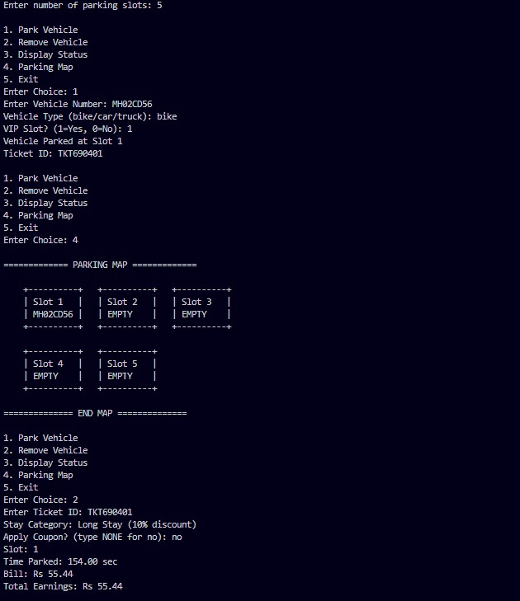

Test Case 3: Coupon Application and Revenue Tracking
Input: Park DL01AB12 (car, non-VIP) for 80 seconds, apply SAVE10 coupon on removal
Output:
The system calculates 80 seconds as 8 billing units. Car rate is Rs 3 per unit, total Rs
24. Medium stay category (30-120 seconds) does not receive time discount. User enters "save10" (lowercase), system converts to uppercase and applies 10% coupon discount: Rs 24 × 0.9 = Rs 21.60. This amount is added to totalRevenue. Display shows: Time Parked: 80.00 sec, Bill: Rs 21.60, and updated Total Earnings.
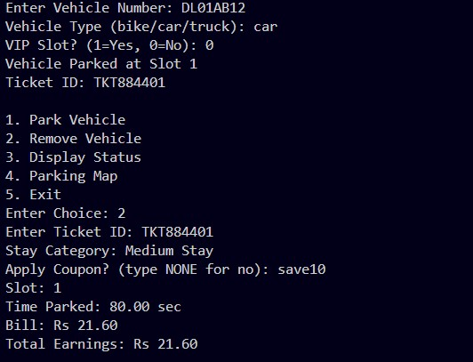

Test Case 4: Invalid Input Handling and Status Display
Input: Attempt to park "bus" type vehicle, try duplicate parking, display status
Output:
When user enters vehicle type "bus", isValidType returns false and system displays "Invalid vehicle type! Only bike, car, truck allowed." preventing the parking operation. If user tries to park DL01AB12 again while it's already parked, isAlreadyParked detects the duplicate and displays "Vehicle already parked." Status display shows: Total Slots: 5, Occupied Slots: 3, VIP Slots Occupied: 1, Available Slots: 2, Total Revenue: Rs 75.60 (cumulative from all transactions).
